|  |  |
| --- | --- |
| Ex No: 6  Date: 11/09/2024 | MNIST Denoising Autoencoder |

**Objective:**

The primary objective of this notebook is to develop a denoising autoencoder utilizing convolutional neural networks (CNNs). The autoencoder is trained to eliminate noise from images of handwritten digits in the MNIST dataset. This exercise illustrates how autoencoders can learn valuable latent representations by reconstructing clean images from noisy inputs.

**Code Explanation for simple_autoencoder:**

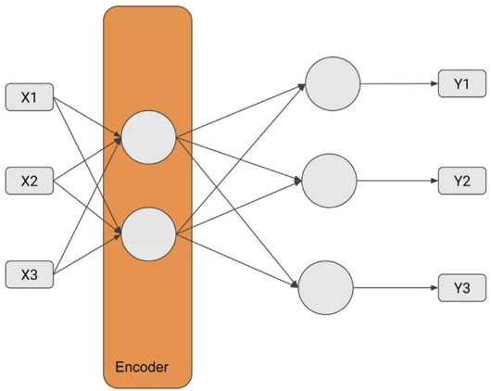 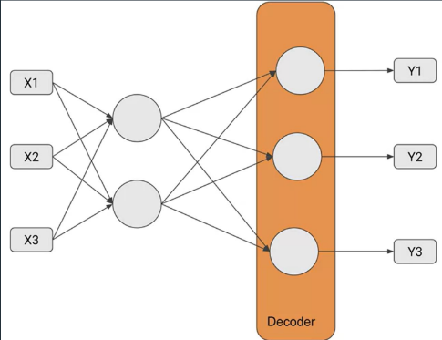

The simple_autoencoder(inputs) function builds a two-layer auto-encoder with the following structure:

* **Encoder**: Reduces the input from 784 units to 32 units through a dense layer with ReLU activation.
* **Decoder**: Reconstructs the input back to 784 units using a dense layer with sigmoid activation.

Two models are built:

* **Encoder Model**: Extracts the compressed representation.
* **Autoencoder Model**: Performs the end-to-end encoding and decoding of the input.

For denoising the data:

The function begins by normalizing the input image, converting it to float32 type and scaling the pixel values from the range [0, 255] to [0, 1]. It then introduces Gaussian noise by generating random noise with the same shape as the image and scaling it by a noise factor of 0.5, which determines the intensity of the noise. This scaled noise is added to the normalized image, producing a noisy version. To ensure the noisy image remains valid, the pixel values are clipped to stay within the [0, 1] range. Finally, the function returns the noisy image as the input and the original clean image as the target for reconstruction.

**Results**

The notebook contains code to visualize the autoencoder's performance by displaying the original images, noisy images, and reconstructed (denoised) images side by side. The model demonstrates effective denoising, successfully reconstructing the images by removing most of the added noise while retaining the key features of the digits. The loss curves and visual results highlight the model's capability to learn the mapping between noisy inputs and clean outputs.

**Result Analysis:**

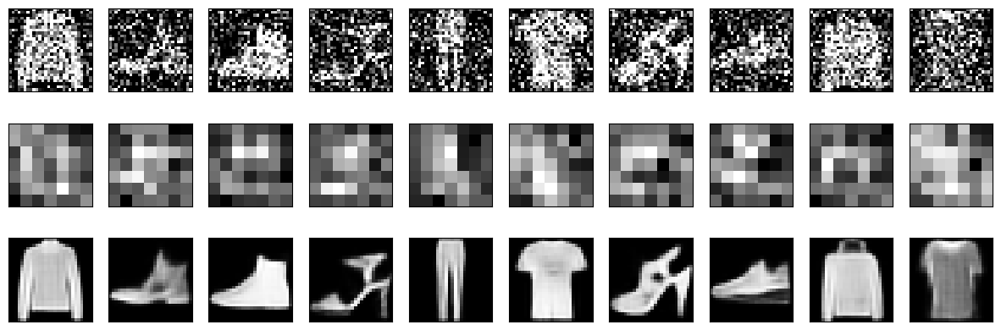

**Summary:**

The notebook showcases the implementation and training of a denoising autoencoder using CNNs and the MNIST dataset. By introducing Gaussian noise to the images, the autoencoder learns to remove the noise and reconstruct the clean versions. The results demonstrate that the model effectively learns meaningful features and excels in reconstructing clean images, as shown by both qualitative and quantitative outputs. This exercise emphasizes the practical application of autoencoders in tasks involving dimensionality reduction and data denoising.

**GitHub Link:**

**https://github.com/Mithungowda6666/Deeplearning/tree/main/lab_6/lab6.4**